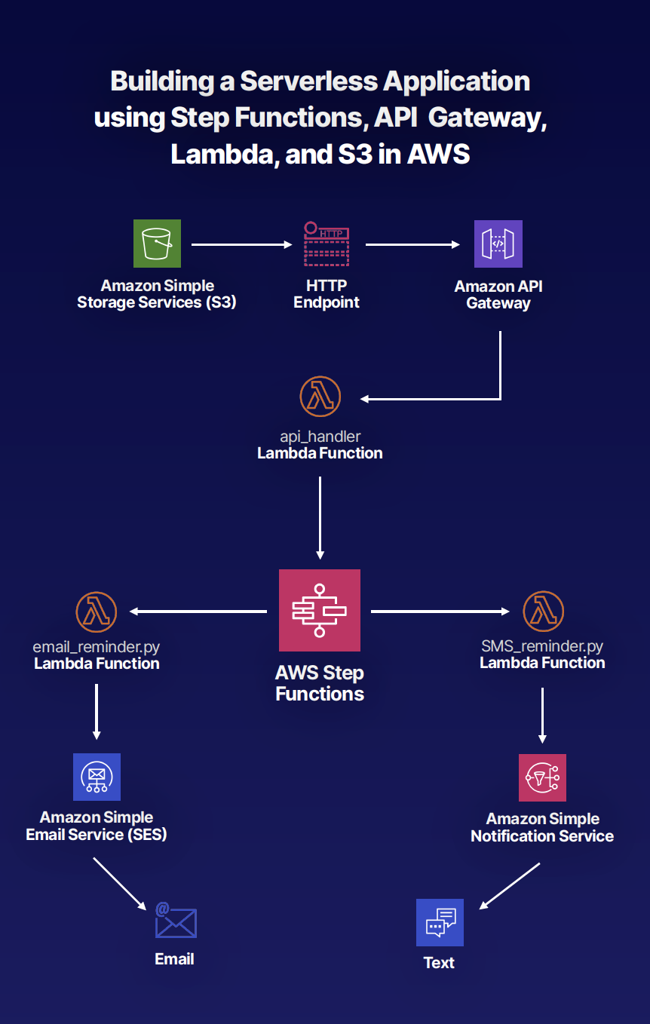

Building a Serverless Application Using Step Functions, API Gateway, Lambda, and S3 in AWS

Introduction
In this AWS hands-on lab, we will create a fully working serverless reminder application using S3, Lambda, API Gateway, Step Functions, Simple Email Service, and Simple Notification Service.
While the lab does use Python and JavaScript, you don't need to be able to code to understand and implement the solution. By the end of the lab, you will feel more comfortable architecting and implementing serverless solutions within AWS.
Let's get started!

Logging In
Log in to the live AWS environment using the credentials provided. Make sure you're in the N. Virginia (us-east-1) region throughout the lab.
If you'd like to follow one of the optional steps below involving the Postman app, you can download the app here.
All of the resources needed to complete this lab are available from this GitHub repo.

Create the email Lambda Function
- Navigate to Lambda in the AWS console, and click Create function.
- Make sure Author from scratch is selected.
- Set the Function name to email, and the runtime to python 3.7.
- Expand Choose or create an execution role, select Use an existing role, and pick our LambdaRuntimeRole from the dropdown.
- Click Create function.
- Scroll down to the Function code section, and replace the code in the lambda_function area with what's in the email_reminder.py file in the GitHub repository.
  - To get the code, navigate to that file in the repository, then click the Raw button. Copy the text on the next screen, then paste it back in the Lambda window (in the Function code section) we've got open.
- Open up a new browser tab, and leave this one open. We'll be back in a minute.

Set up an Email Address
- Navigate to Simple Email Service.
- Click Email Addresses, then Verify a New Email Address. Enter an email address to use, then click Verify this address.
  - Check the email address, open up the verification email that AWS sent, and click the link. We should land on a Congratulations! page telling us that the email address has been verified.

Finish the Lambda Function Setup
- Change YOUR_SES_VERIFIED_EMAIL to the email address that just got verified.
- Click Save.

Create the sms Lambda Function
- Navigate again to the main Lambda page in the AWS console, and click Create function.
- Make sure Author from scratch is selected.
- Set the Function name to sms, and the runtime to python 3.7.
- Expand Choose or create an execution role, select Use an existing role, and pick our LambdaRuntimeRole from the dropdown.
- Click Create function.
- Scroll down to the Function code section, and replace the code in the lambda_function area with what's in the sms_reminder.py file in the GitHub repository.
  - To get the code, navigate to that file in the repository, then click the Raw button. Copy the text on the next screen, then paste it back in the Lambda window (Function code section) we've got open.
- Click Save.

Create the api_handler Lambda Function
- Navigate again to the main Lambda page in the AWS console, and click Create function.
- Make sure Author from scratch is selected.
- Set the Function name to api_handler, and the runtime to python 3.7.
- Expand Choose or create an execution role, select Use an existing role, and pick our LambdaRuntimeRole from the dropdown.
- Click Create function.
- Scroll down to the Function code section, and replace the code in the lambda_function area with what's in the api_handler.py file in the GitHub repository.
  - To get the code, navigate to that file in the repository, then click the Raw button. Copy the text on the next screen, then paste it back in the Lambda window (in the Function code section) we've got open.
- Click Save.
  - Note that we'll have to come back and edit this a bit, changing the SFN_ARN.

Create a Step Function State Machine
- In a new browser tab, navigate to the Step Functions console. Click the here in You can also skip and access more functionality here up at the top of the page.
- Make sure Author with code snippets is selected, and leave the Type set to Standard.
- In our GitHub browser tab, navigate to the step-function-template.json file, click the Raw button, and copy the next on the resulting screen.
- Paste that code into the Definition section in the Step Functions window we have open.
- Replace any occurrences of EMAIL_REMINDER_ARN with the ARN of the email Lambda function, and any occurrences of TEXT_REMINDER_ARN with the ARN of the sms Lambda function.
  - You'll have to navigate into each of those functions, in the Lambda console, to get their ARNs. Just get into each function's configuration page, and the ARN is in the upper right of the screen.
- Click the refresh button, to the right of the code pane, to update the diagram.
- Click Next
- On the next form, MyStateMachine is fine for a State machine name. Select Choose an existing IAM role in the Permissions section, and choose RoleForStepFunction from the dropdown.
- Click Create state machine.
- Copy the state machine's ARN that shows on the next screen.
- Back in our api_handler page (which should still be open in a browser tab), in the Function code section, we need to replace STEP_FUNCTION_ARN with the actual ARN we just copied.
  - It should read like this: SFN_ARN = WhatWeJustCopied
- Click Save.

Create the API Gateway
- In the AWS console, navigate to API Gateway, click Get Started, and then click OK on any welcome message that might pop up.
- Select REST as a Protocol, and New API right below that.
- Set the API name and Description to reminders, and set the Endpoint Type to Regional.
- Click Create API.
- Click the Actions dropdown and select Create Resource.
- Call it reminders, and check the box to enable Enable API Gateway CORS.
- Click Create Resource.
- Select /reminders, and click Actions > Create method.
- In the dropdown under /reminders (in the Resources pane), select POST and then click the checkmark next to it.
- With POST selected, set the form to the right like this:
  - Integration type: Lambda Function
  - Use Lambda Proxy Integration: Checked
  - Lambda Region: us-east-1
  - Lambda Function: api_handler
- Click Save.
- Click OK to allow API Gateway permission to invoke the api_handler function.
- Select Actions and Deploy API.
- Set Deployment stage to New Stage.
- Give it a Stage name and Stage description of prod.
- Click Deploy.
- Ignore any errors involving WAF.
- Note the Invoke URL that is now at the top of the page. Leave this page open, because we will need this soon.

Create the Static S3 Website

Configure the Static Website
- Open the S3 console.
- Click Create bucket.
- Give the bucket a unique name, and ensure the region is US East (N. Virginia).
- Click Next.
- Click Next again.
- Ensure no checkmarks are selected on the block public access screen. This includes individual ones and any group check mark. In the window that pops up, check the box to acknowledge that these settings may make this bucket and its objects public.
- Click Next and then Create bucket.
- Open the bucket.
- Click Upload
  - If you haven't already, download the GitHub repository.
  - Then click Add files, select the all of the files from the static_website folder, and click Next.
- Change the Manage public permissions dropdown to Grant public read access to this object(s).
- Click Next, then Next again, and finally Upload.
- Now click the + Create folder button, give it a name of images, and click Save.
- Click on the newly created images folder and click Upload.
- Browse to the downloaded GitHub repository and select cat.png.
- Change the Manage public permissions dropdown to Grant public read access to this object(s).
- Click Next, then Next again, and finally Upload.
- Navigate back out to the main bucket screen, and click the Properties tab.
- Click Static website hosting.
- Select Use this bucket to host a website.
- Enter index.html in the Index Document box, and error.html in the Error Document box.
- Click Save.
- Select Static website hosting again and click on the Endpoint URL.
- Test it out:
  - Fill out the form underneath the cat picture:
    - Seconds to wait: 1
    - Message: hello
    - Email address: Just enter a valid email here
    - Telephone: We can leave this blank
    - Click the email button below the form.
  - We'll get an error, because we didn't update formlogic.js

Updating formlogic.js
- Back in the API Gateway browser tab that we should still have open, copy that Invoke URL.
- With a text editor, find formlogic.js in the downloaded GitHub repository.
- Replace the YOUR_API_ENDPOINT_URL placeholder text with the invoke URL we just copied, and add /reminders to the end of it.
- Upload it to the S3 bucket like we did before (replacing the existing formlogic.js that's already up there).
- Get back into the browser tab we had open to the Endpoint URL, and fill out the form again, using the same values we did before. This time when we click the email button, we should get both a Looks ok and a {"Status":"Success"} message (one above and one below the form).
- Now let's check our email, and we should have one sitting there with a subject line of A reminder from your reminder service!. If we click into the email, we'll see our hello message.
- If we'd chosen sms or both when choosing which method to use for notification, then we need to make sure the phone number we type includes a +1 and area code before the rest of the phone number, like this:
  - +19998675309

Seeing What Happened
If we want to see the process that occurred, navigate to Step Functions in the AWS console, then State machines, and click on MyStateMachine. Down in the Executions section, we should see one with a status of Succeeded. Click on that event's name, and we can look at the Visual workflow diagram. It will show the order of events that occurred when we submitted the form.

Conclusion
We set up a little application uses several AWS components to send us reminder messages based on what we enter into a web form. Congratulations!

